

Numerical Analysis

SUBMITTED TO:

SIR HASEEB

SUBMITTED BY:

M QASIM NAUMAN - 221345

CLASS: BSCS-5(B)

DEPARTMENT OF COMPUTER SCIENCE

AIR UNIVERSITY ISLAMABAD

**LAB MID**

# **Question 1:**

## **PART 1 – Input 5 number, calculate the sum of the highest 3**

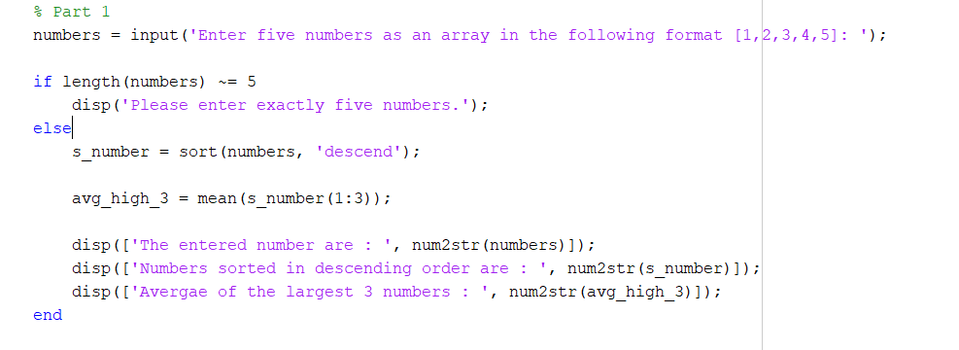

## **Output:**



## **PART 2 – 3D graph of the given functions**

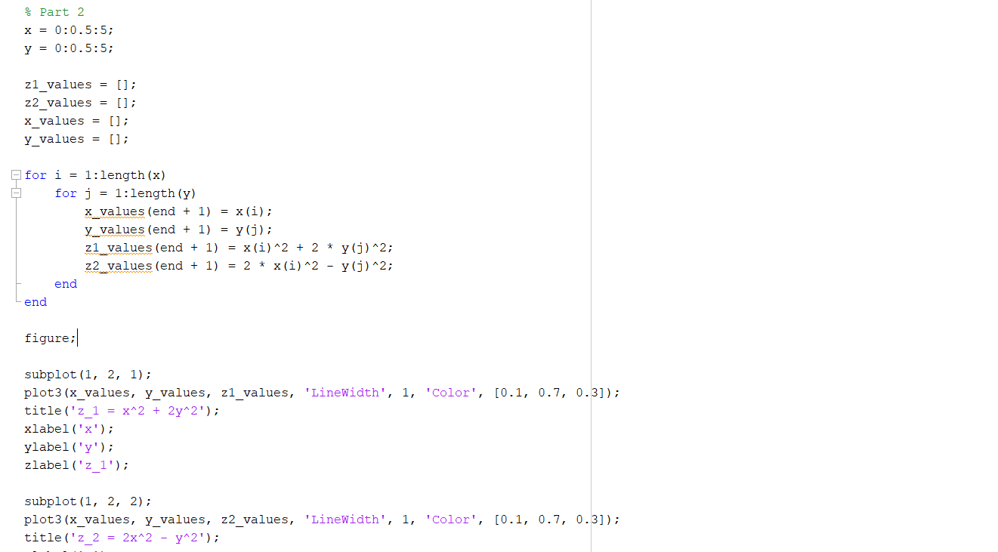

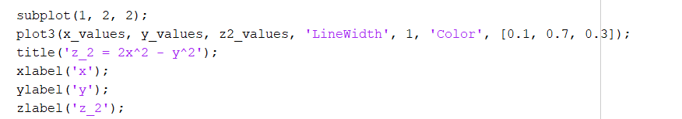

## **Output:**

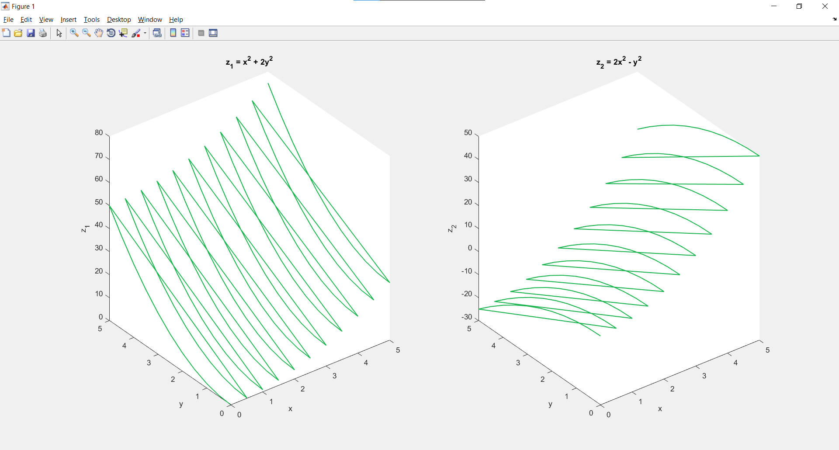

# **Question 2:**

## Algorithm:

* The first step is to give the input which is always a continuous function along with the derivate of it. Lets say the function as F(x) and F’(x) as the derivate
* Next we initialize the values of x0 and x1 which can be given and if not we start it from zero
* Next we calculate the approximation using the formula

x(n+1) = x(n) – f(x(n)/f’(x(n))

* Next we check the convergence, if | x(n+1) – x(n) | < tol then we assume the x(n+1) as the root;
* We repeat until the difference is smaller than tolerance.
* Display the output

## **Code to get the answer of given function**

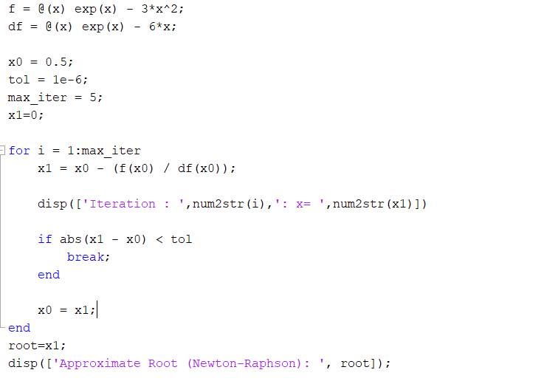

## **Output:**

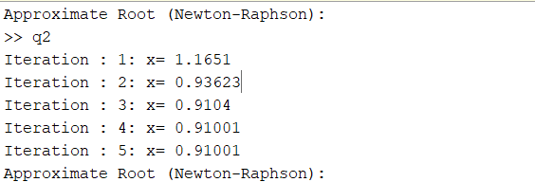

# **Question 3:**

## **For Loop to print the sum of even number is range of 1 to 20**

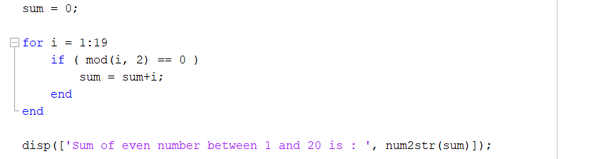

## **Output:**



## **While loop to print the square of numbers below 50**

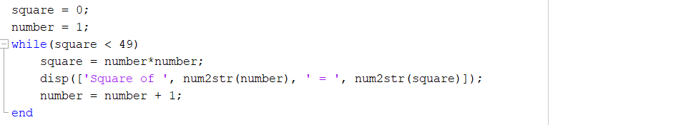

## **Output:**

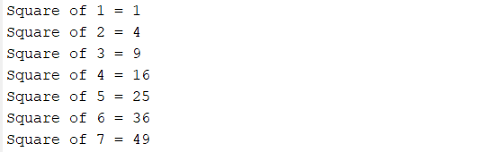

## **Loop breaking on a condition**

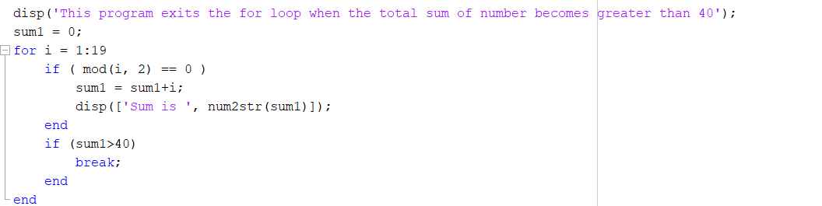

## **Output:**

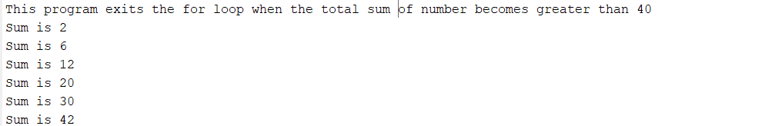

# **Question 4:**

## **Code using Newton Forward Method**

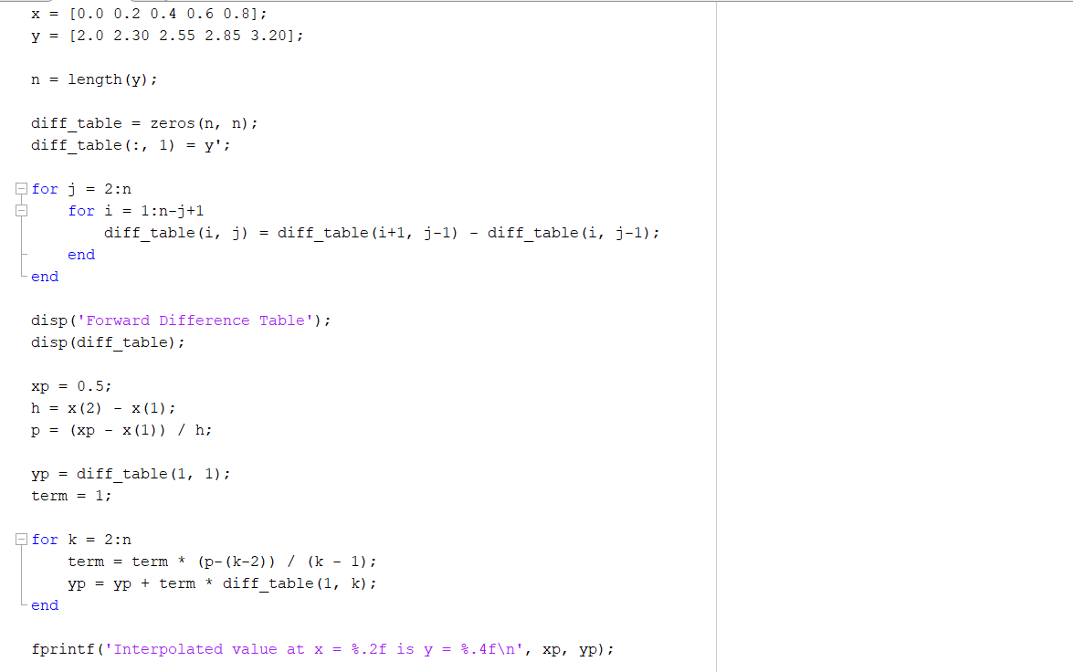

## **Output:**

